|  |  |  |  |  |  |  |  |  |  |
| --- | --- | --- | --- | --- | --- | --- | --- | --- | --- |
| ID | Summary | Descriptions | Steps to reproduce | Reproducibility | Severity | Priority | Symptom | Workaround | Comments |
| ST.1.5.1 | Empty audio file was processed instead of writing an error message | If an empty audio file is put inside mandatory or optional directory, the app ignores the fact it is empty and processes it instead of writing an error message in the console output.  **Exp:** the app starts, writes standard usage message (DS-2.2), writes error message “No audio header or audio tag data in: {full path}” in the console and shutdown.  **Act:** empty audio file is processed without any errors and is added to catalog.  **Req:** DS-2.4, DS-3.2(p.3) | 1. Create an empty directory. 2. Put an empty .mp3 audio file in it. 3. Start the app and use this directory as StartingDirectory1 parameter.   **Bug:** the empty audio file appears in catalog, no error messages are written in console. | Always | Major | Normal | Incorrect file structure integrity analyzer | No | If an empty/broken audio file is found it should be skipped with a proper error message. |

Attachment to report ST.1.5 

|  |  |  |  |  |  |  |  |  |  |
| --- | --- | --- | --- | --- | --- | --- | --- | --- | --- |
| ID | Summary | Descriptions | Steps to reproduce | Reproducibility | Severity | Priority | Symptom | Workaround | Comments |
| ST.1.5.2 | Empty .mp3 file was processed with “null” console message instead of error message | If an empty .mp3 file is put inside the directory, the app ignores the fact it is empty and processes it instead of writing an error message in the console output.  **Exp:** the app starts, processes files, finds an empty file, writes error message “No audio header or audio tag data in: {full path}”, skips empty file and continue its work.  **Act:** the app writes “null” message in console, empty file is added to catalogue, app continues its work.  **Req:** DS-2.4, DS-3.2(p.3) | 1. Create an empty directory. 2. Put an empty .mp3 audio file in it. 3. Start the app and use this directory as StartingDirectory1 parameter.   **Bug:** app finds an empty .mp3 audio file and writes “null” message instead of error message in console. | Always | Minor | Normal | Incorrect error log messenger | No | According to the requirements if an empty audio file is found, the app should write proper error message and continue its work. |

Attachment to report ST.1.5.2

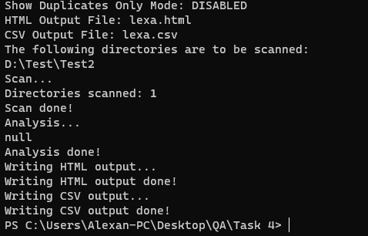

|  |  |  |  |  |  |  |  |  |  |
| --- | --- | --- | --- | --- | --- | --- | --- | --- | --- |
| ID | Summary | Descriptions | Steps to reproduce | Reproducibility | Severity | Priority | Symptom | Workaround | Comments |
| ST.2.1.1 | Processing empty .wma file leads to exception | If an empty .wma file is put in a processed directory, the app cannot process it and stops with an exception in console log.  **Exp:** the app starts, processes files, finds an empty file, writes error message “No audio header or audio tag data in: {full path}”, skips empty file and continue its work.  **Act:** app stops with an exception in console log.  **Req:** DS-2.4, DS-3.2(p.3) | 1. Create an empty directory. 2. Put an empty .wma audio file in it. 3. Start the app and use this directory as StartingDirectory1 parameter.   **Bug:** app finds an empty .wma audio file and stops with an exception in console log. | Always | Medium | Normal | Incorrect .wma analyzer | No | Something is wrong exactly with .wma tag reader if file is empty. |

Attachment to report ST.2.1.1

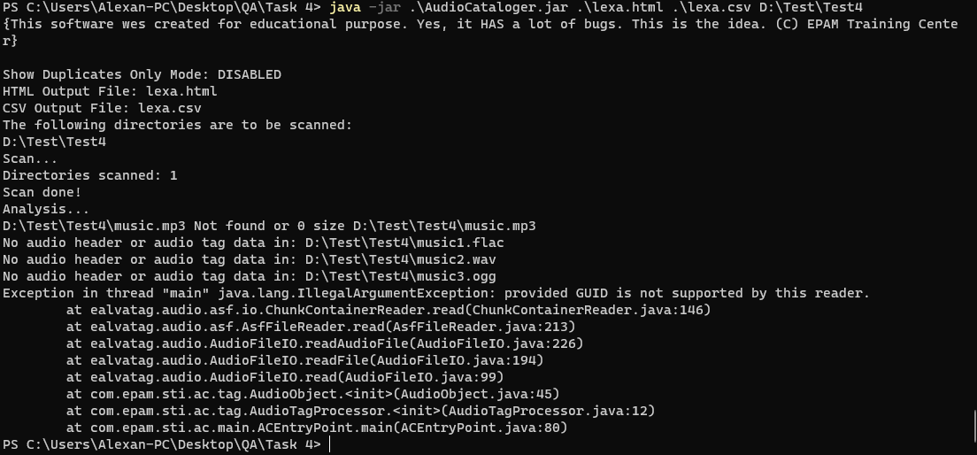

|  |  |  |  |  |  |  |  |  |  |
| --- | --- | --- | --- | --- | --- | --- | --- | --- | --- |
| ID | Summary | Descriptions | Steps to reproduce | Reproducibility | Severity | Priority | Symptom | Workaround | Comments |
| ST.2.1.2 | FIles with no audio tags and different names are marked as **Duplicate** | If the app processes files with no audio tags in, it marks them as **duplicate** though the file names are different.  **Exp:** the files with different names are not written in output as duplicates.  **Act:** files with different names are marked as **duplicates.**  **Req:** DS-2.1 | 1. Create an empty directory. 2. Put some empty/broken tags audio files in. 3. Start the app and use this directory as StartingDirectory1 parameter.   **Bug:** app adds incorrect files to catalog and marks them as duplicates. | Always | Medium | Normal | Incorrect duplicate analyzer | No | This bug most likely come from bug №1.5.2 |

Attachment to report ST.2.1.2

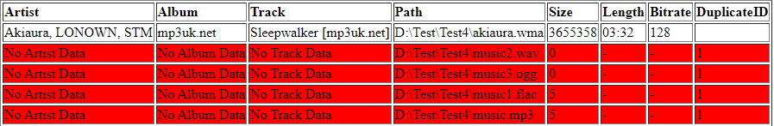

|  |  |  |  |  |  |  |  |  |  |
| --- | --- | --- | --- | --- | --- | --- | --- | --- | --- |
| ID | Summary | Descriptions | Steps to reproduce | Reproducibility | Severity | Priority | Symptom | Workaround | Comments |
| CPT.2.3 | Unsupported audio file is ignored with no console message | If the app processes files with of unsupported types, it skips them without any messages  **Exp:** the app processes files and writes “No audio header or audio tag data in: {full path}” to console.  **Act:** the app skips the file with no messages in console.  **Req:** DS-5.3 | 1. Create an empty directory. 2. Put some unsupported files in. 3. Start the app and use this directory as StartingDirectory1 parameter.   **Bug:** app ignores the unsupported files, no error message is written. | Always | Minor | Normal | Incorrect file type analyzer | No | According to the requirements the app should write an error message to console before skipping the unsupported file |

Attachments to report CPT.2.3

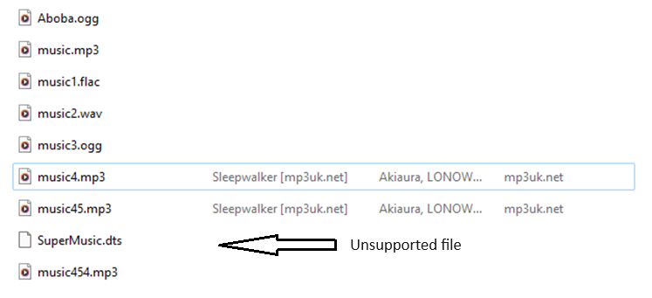

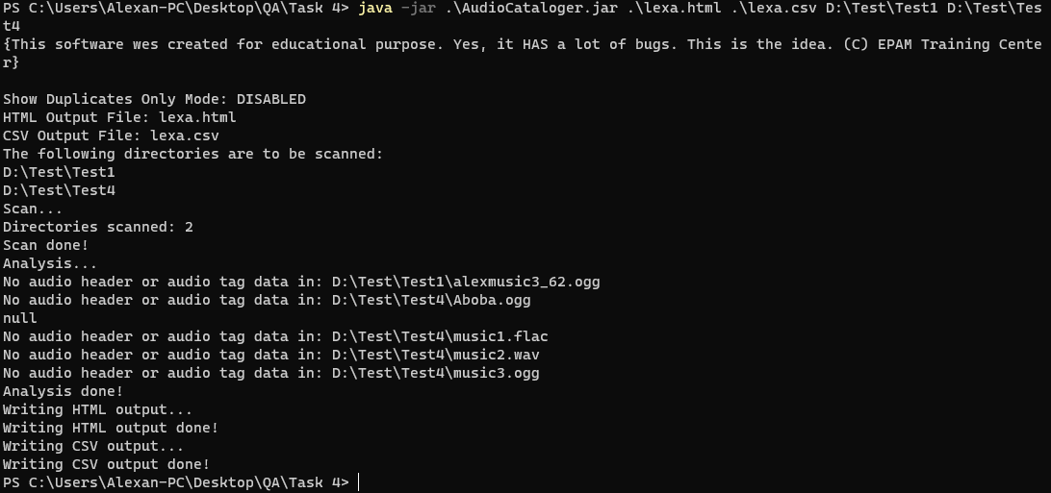

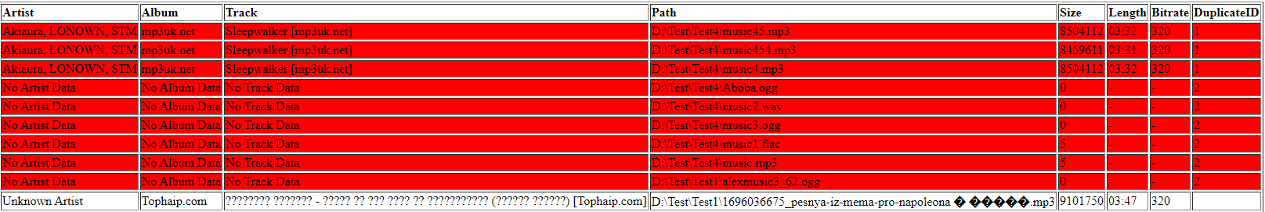

|  |  |  |  |  |  |  |  |  |  |
| --- | --- | --- | --- | --- | --- | --- | --- | --- | --- |
| ID | Summary | Descriptions | Steps to reproduce | Reproducibility | Severity | Priority | Symptom | Workaround | Comments |
| CPT.2.4 | Broken file is added to catalog | The app processes a broken instead of writing an error message in the console output and skipping it.  **Exp:** the app processes files and writes “No audio header or audio tag data in: {full path}” to console.  **Act:** broken file is added to catalog with no error messages.  **Req:** DS-2.1 | 1. Create an empty directory. 2. Put some broken audio files in. 3. Start the app and use this directory as StartingDirectory1 parameter.   **Bug:** app adds broken files to catalog, no error messages written. | Always | Major | Normal | Incorrect file structure integrity analyzer | No | This bug most seems to be the same as  ST.1.5.1. Maybe the app should files with insufficient data (tags) as broken |

Attachment to report CPT.2.4

